
Essentials Mathematics
Practical Application
Task 2.11
In Class Investigation

Name:______________________

Bonus marks are available for: | Possible score | Your score
Argument: formulae, use of equal signs (=), showing all working | 1
Numbering and writing: easily read | 1
Units: stated where appropriate | 1

This investigation is to be completed during class time. Total marks: 65

You must give reasons and/or working to justify all of your responses.

You should make use of as many concepts from normal class work as you can.

Introduction

Greg has applied for a job in Melbourne (Victoria) and has been offered an interview. The company will pay for an economy airfare.
His interview will be over a dinner in Melbourne on Thursday, March 14.

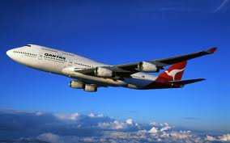

- Greg lives in Geraldton and needs to have a few things organised before he goes to Melbourne.
- He has needed a car for a while now and this will be the best time to get one.
- Greg has gathered some data on two makes of cars, Voertuig and Coche.

Vehicle | Automatic (A) or  Manual (M) | City consumption  (L/100km) | Highway consumption  (L/100km) | Engine size (L)
 | A | 9.5 | 5.6 | 1.6
 | M | 8.5 | 5.6 | 1.6
Voertuig | A | 11 | 6.8 | 2
 | M | 10.5 | 6.6 | 2
 | A | 18 | 12.5 | 3.2
 | M | 17 | 11 | 3.2
 | A | 9 | 6.6 | 1.6
 | M | 8 | 6 | 1.6
Coche | A | 11 | 6.6 | 2
 | M | 9 | 5.4 | 2
 | A | 12.5 | 7.8 | 4
 | M | 12 | 7.8 | 4

Question 1. [2, 2 = 4 marks]

How many Litres of fuel would be consumed if the 2L manual Voertuig was driven:

(a) 400km on a highway?

(b) 50km in the city?

Question 2. [2, 1 = 3 marks]

Fully identify the car that has the best fuel consumption for:

(a) city driving.

(b) highway driving.

Question 3. [2, 2 = 4 marks]

(a) Greg believes the data shows he should get a small, automatic car. Do you agree? (Only the reasons will be marked, not ‘yes’ or ‘no’.)

(b) If fuel consumption was the only consideration, which car would be best to buy? Justify your answer.

Question 4. The data collected by Greg are important considerations when deciding which car to buy. However, he has not included other things that would be important in his situation. Give two different issues he should also consider. [ 2 marks]

Question 5. Greg has found a car to buy, however it costs $12000. He only has $2000 saved, so decides to borrow the rest of the money from a bank. He takes out a loan at 8.7% p.a. for 3 years. [ 3 marks]

(a) How much does he borrow from the bank?

(b) How much interest will be charged over the 3 years?

(c) How much, IN TOTAL, does he have to repay to the bank?

Question 6. This money must be paid back to the bank. Greg chooses to make monthly repayments for 3 years. [ 2 marks]
(d) How much will each monthly payment be?

(e) How much will he have paid IN TOTAL for the car?
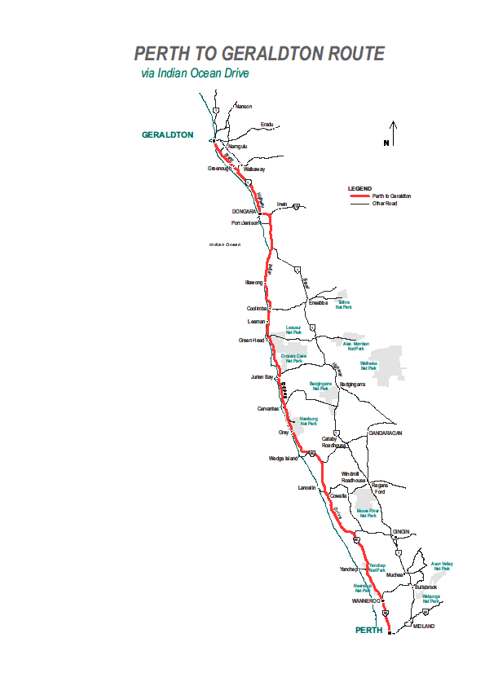

Question 7. [ 3 marks]

The distances between Perth, Lancelin, Cervantes, Jurien Bay and Geraldton along Indian Ocean Drive is shown in the table below.

 | P | L | C | J | G
P | - | 126 | 198 | 220 | 415
L | 126 | - | 72 | 94 | 289
C | 198 | 72 | - | 22 | 217
J | 220 | 94 | 22 | - | 195
G | 415 | 289 | 217 | 195 | -

Determine an approximate scale for the map.
You may give it in whichever form you wish: Fractional scale, Written description or graphic scale.
Show reasoning clearly.

Question 8. [4 marks]

Greg is driving from Geraldton to Perth Airport to catch his flight to Melbourne. The map below shows the driving time (in minutes) between various towns along the way.

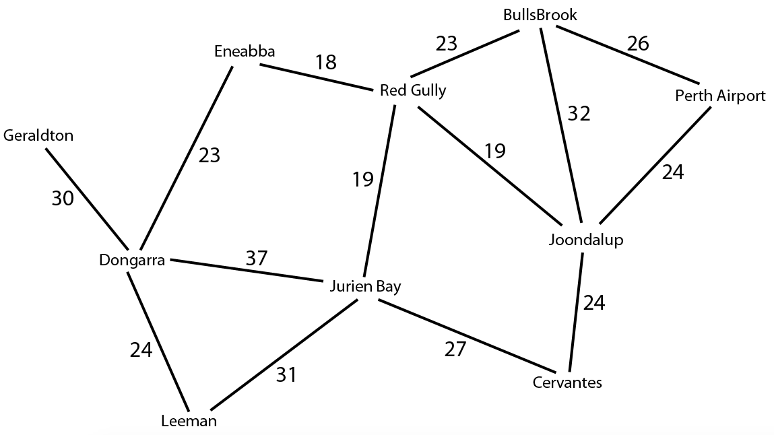
46
56
47
81
28
107
110
18
68
89
110
30
33
35

- Calculate the fastest route from Geraldton to Perth Airport.

- State this route and the time taken.

Greg’s mother wants him to drop a fruitcake off to his Aunt Mabel who lives in Leeman.

- What route should he now take, and how long will it now take for him to get to Perth Airport?

Question 9 [1,3,1,2: 7 marks]

Greg has decided to leave for Perth at 0630 from Geraldton.
Below is a graph of part of this trip.

- At what time did Greg have his first stop and how long is it?

- How fast was Greg travelling after his second stop?

- How fast did Greg travel on average?

- What time does the graph stop recording?

Question 10. [3 marks]
On the drive down from Geraldton, Greg needed to buy a drink. The service station he stopped at has a special.

375 mL cola for $2.60 or 600 mL cola for $4.00

- Which is the better buy? Show working for marks to be awarded.

Greg can not afford to spend more time in Melbourne than he must.

Question 11. [ 1, 1 = 2 marks]

He had to remind himself of the time-zone differences between cities in Australia. An internet search he did that afternoon showed the following clocks for Perth, Adelaide and Brisbane. (Remember that these are the times in each city at the same moment.)

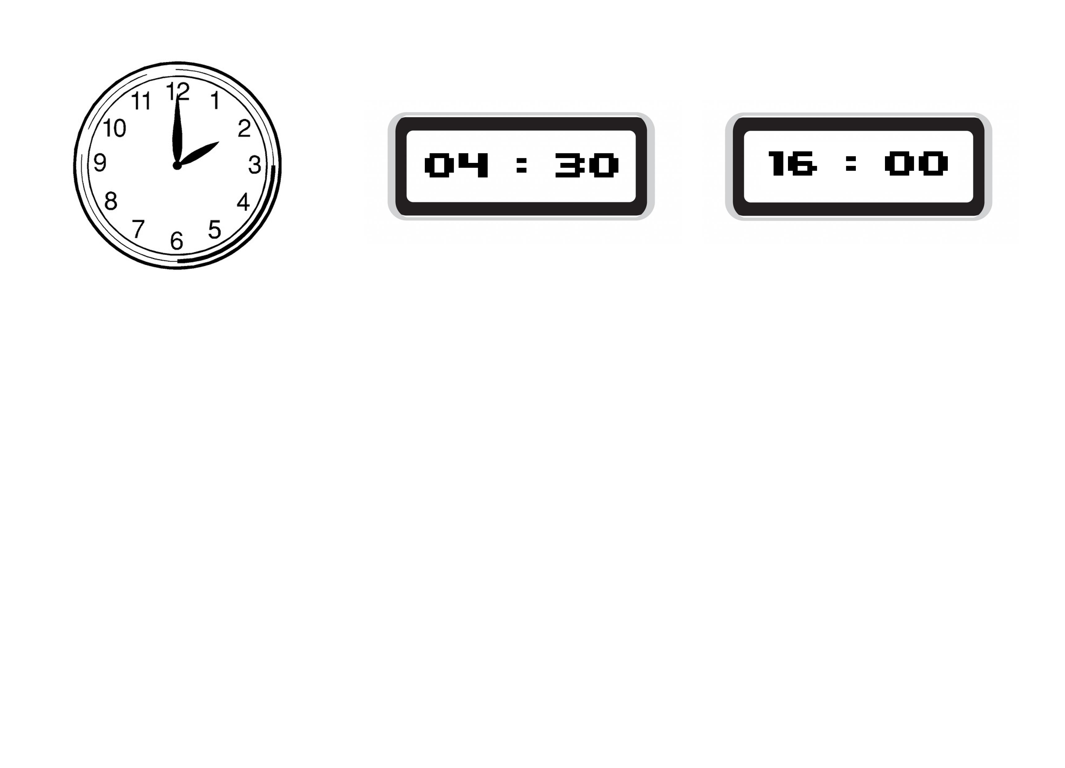
(2pm) (12 hour clock)
Perth Adelaide Brisbane
What is the time difference between:

(a) Perth and Adelaide? (b) Adelaide and Brisbane?

Greg then looked up the flight times for the day he had the interview.
He saw the first plane left Perth at 6.10am and arrived in Melbourne at 12.45pm.
Flights Out
From |  | To
06:10 | Perth | 12:45 | Melbourne

Question 12. [2 marks]
- Calculate the flight time for this trip. Note: Melbourne is 3 hours ahead of Perth.

The dinner in Melbourne was for 7.00pm at a restaurant in the city.
It usually takes 1 hour and 30 minutes to collect luggage and catch a taxi to the city from the Melbourne airport. The taxi can drop Greg at the restaurant in this time.
Question 13. [ 3, 2 = 5 marks]

- What is the latest time that Greg can leave Perth to be sure he will get to the restaurant on time?
Show your reasoning carefully.

- If you were Greg, would you leave at this time? (ie. At the time you said in number 3a?)
Give reasons for your answer.

Question 14. [2 marks]

Greg noticed that he could catch a plane from Perth that landed in Adelaide on the way to Melbourne. Two different planes leave Perth at 8:25 and land in Adelaide at 13:50.

If Greg decided to catch one of these planes,
which would you suggest he take. Why?

Flights Out
From |  |  | To
06:10 | Perth |  | 12:45 | Melbourne
08:35 | Perth |  | 15:10 | Melbourne
09:50 | Perth |  | 16:25 | Melbourne
10:50 | Perth |  | 17:25 | Melbourne
12:50 | Perth |  | 19:25 | Melbourne
14:30 | Perth |  | 21:05 | Melbourne
17:05 | Perth |  | 23:40 | Melbourne
17:50 | Perth |  | 00:25  (Fri) | Melbourne
23:35 | Perth |  | 06:10  (Fri) | Melbourne
From |  |  | To
08:25 | Perth |  | 13:50 | Adelaide
14:35 | Adelaide |  | 16:25 | Melbourne
08:25 | Perth |  | 13:50 | Adelaide
15:35 | Adelaide |  | 17:25 | Melbourne
09:05 | Perth |  | 16:20 | Sydney
17:00 | Sydney |  | 18:35 | Melbourne

Greg arrived in Melbourne on time and met Marissa at the restaurant. Marissa is the Manager of a New Zealand company with an office in Melbourne. She was with two other people from the company, Peter and Paulla
The menu at the restaurant included:
(Note that each dish has a number.)

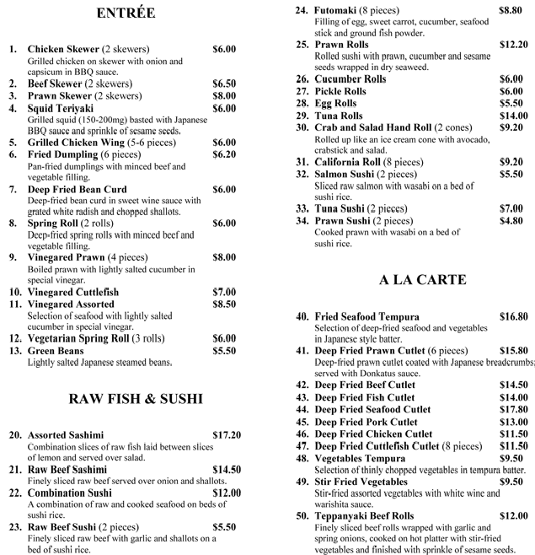

They decided to share different dishes, and so they ordered the following:

Dish number | Number of those dishes ordered
1 | 2
3 | 4
4 | 1
11 | 1
20 | 2
23 | 3
24 | 1
41 | 2
48 | 3

Greg used the calculator on his smart-phone to calculate the total cost of the food.

Question 15 [2, 1, 2 = 5 marks]

(a) Peter estimated the total to be $230 by rounding the cost of each dish up to the nearest $10. (i) Describe a better way to estimate the total cost.

(ii) Show clearly how you would estimate the total cost, and state your estimate.

(b) Find the actual total cost.

(c) Greg typed in: 12 + 32 + 6 + 8.5 + 34.4 + 15.5 + 8.8 + 31.6 + 28.5
He got a total of $177.30, but made one mistake.

(i) Can you describe why Greg entered the numbers he did?

(ii) What one error did Greg make?

It’s all about the Money

Greg was told that if he got the job, he would be paid $120 000 per year. He thought that was great, until he realised that Marissa meant New Zealand dollars.

Question 16 [2 marks]

One Australian dollar is worth 0. 7946 New Zealand dollars. ( ie. AUS$1 = NZ$0.7946)

How much will Greg earn in Australian dollars, if he accepts the job?

The name of the company that Marissa manages is called Fire-up. They make cable that is intended for electronic devices. The cable is imported from New Zealand in two rolls. One roll contains 100m of cable and weighs 250g. The other roll is 300m long and weighs 800g.

 | Length | Weight
Small roll | 100 metres | 250 grams
Large roll | 300 metres | 800 grams

Question 17 [2, 3, 4 = 9 marks]

(a) Greg was asked how he would fill an order for 1km of cable. What answer would you give if you were Greg?

(b) (i) How many metres are there in 11.52km?

(ii) How would you fill an order for 11.52km of cable?

(c) Small rolls of cable are sold for $100 each and large rolls are sold for $280.

 | Price
Small roll | $100
Large roll | $280

(i) How much would it cost a customer for 11.52km of cable if the order was filled the way you answered in (bii) above?

(ii) Is there another way of filling the order that would cost the customer less?
Be thorough in giving your answer.

End of Assessment

